**Avoid**

**Easement and Covenants**

*Overview:*

An easement or covenant is a legal agreement that allows the owner of a parcel of land to grant rights to others for a designated use.1 In Canada, except for Quebec, covenants and easements are authorized by either common law or statute. 16 Easements grant the right of access to a passageway through a property.3 In common law, an easement is attached to the land that benefits from the easement. Hence, the easement belongs to who owns the land. 16 Easements and covenants can serve as important strategies in climate change adaptation planning. For example, as an avoidance measure, a municipality may acquire a conservation easement to inhibit development in coastal areas that are susceptible to sea-level rise and flooding due to storm surges. Additionally, a covenant can be negotiated with landowners to prevent the construction of hard structures such as docks and sea walls that can prevent the migration of marshes and dunes inland. 5

*Types of easements and covenants:*

* **Conservation easements** are legal agreements that are registered on the title between a landowner and a qualified organization, e.g., a conservation organization, land trust, or government agency. The easements provide long-term protection for the property. Some conservation easements may provide protection for as much as 999 years. 12
* **Property easements of prescription** apply to rights that have been enjoyed for 20 years without interruption or consent by a servient landowner.However, specific requirements must be met before property easement rights can be enjoyed. For example, if the property owner provides the user with permission every 20 years, easement by prescription does not arise.
* **An express grant** means that a right of way has been expressly grantedand that the right will be registered on the title in a land registry. Express grants typically apply where the owner of a servient property grants an easement for the benefit of one or more properties
* **An implied grant** is a legal document that provides for the establishment of an easement when it is necessary for the use and enjoyment of property. For example, if a property owner severs a lot but does not register an easement for access and the lot that is severed is landlocked.13, 14

*Benefits:*

* An easement or other restriction can be limited to a particular part of a site, a particular purpose, or a specific period.
* The owner can retain ownership of the property and may be able to use areas, not at risk.
* The cost for a covenant or statutory right-of-way is typically much less than a fee simple acquisition.
* A covenant may be used in conjunction with other tools such as a subdivision, building, or land use regulation.
* A conservation easement may be considered a charitable gift by the Canada Revenue Agency.
* A covenant may be negotiated as part of the development approval process with no direct cost to the local government.

*Challenges*

* Once established, an easement cannot be used in a manner that is contrary to the purpose for which it was created.
* An easement may not be removed easily. Even if the dominant user is not using the easement this does not constitute sufficient grounds to release the easement.
* Hydro easements may limit the use of a landowner’s property. Hydro companies have the right to enter a property to lay cables, or erect poles 13
* The establishment of an easement is likely to lead to a decrease in future property value 15
* An annual compensation or a lump sum payment may be required to secure the easement or statutory right of way process or servitude. 17

*Coastal South Carolina Rolling Easement (SC, USA):*

Along the coast of South Carolina, a rolling easement system was implemented on the seaward side of the setback line using the Beach Front Management Act in 1990.5 A rolling easement typically rolls landward to allow for the migration of coastal vegetation. Thus, it restricts property owners from using hard shoreline protection.6 The easement line is defined by the new vegetation line.7 This tool has been implemented across several coastal communities in the United States.

*Texas Open Beaches Act (TX, USA):*

In 1959, the Texas Open Beaches Act (TOBA) was passed to maintain public access along the Gulf shores through a rolling easement concept.8 In the TOBA, a rolling easement is defined as the area between the vegetation line and the mean low tide line. Therefore, public access to beaches is not static.9 Like many other rolling easements, the TOBA prohibits property owners from using hard shoreline protection that would impede public access to a beach.10 Ownership of property does not change with the TOBA; however, it requires landowners to protect the public’s right of access.11 The rolling easement is critical to the migration of the Gulf’s coastal wetlands which provides a habitat for many endangered species.

*References:*

1. The Arlington Group Planning Architecture Inc., et al. *Sea Level Rise Adaptation Primer*. pp. 53. https://www2.gov.bc.ca/assets/gov/environment/climate-change/adaptation/resources/slr-primer.pdf
2. Ibid, 53.
3. Ibid, 53.
4. Ibid, 55.
5. Bergeron, Mary. “Coastal South Carolina.” *Louisiana Resiliency Assistance Program*, Louisiana Resiliency Assistance Program, 6 Nov. 2017, https://resiliency.lsu.edu/case-studies-blog/2017/11/6/coastal-south-carolina.
6. Ibid.
7. Ibid.
8. “Rolling Easements & the Texas Open Beaches Act.” *Coastal Resilience*, https://coastalresilience.tamu.edu/home/wetland-protection/policy-framework/bay-and-ocean-side-submerged-lands-some-fundamental-differences-in-law-and-management/the-texas-open-beaches-act-an-exceptional-example-of-a-rolling-easement/.
9. Ibid.
10. Ibid.
11. Ibid.
12. Thompson, M. J. (n.d). CONSERVATION EASEMENTS. Ontario Nature-Federation of Ontario Naturalists. <https://ontarionature.org/wp-content/uploads/2017/10/Conservation_Easements.pdf>
13. Humingbird Progressive Legal Counsel. (n.d). Why Are You On My Land? Property Easements In Ontario Are Forever (Almost). <https://www.hummingbirdlaw.com/property-easements/>
14. Little et al. (2004). EASEMENTS, COVENANTS AND SIMILAR RIGHTS IN BRITISH COLUMBIA – AN OVERVIEW. http://saltspringrealestateagent.com/wp-content/uploads/2012/06/DWL_AMW_MCM_EASEMENTS_COVENANTS__SIMILAR_RIGHTS_IN_BC.pdf
15. Murray Wise Associates LLC. (2019). Conservation Easements – Some Things To Think About. <https://murraywiseassociates.com/conservation-easements-some-things-to-think-about/>
16. Environment Canada. (2004). CONSERVATION EASEMENTS, COVENANTS AND SERVITUDES IN CANADA. A Legal Review. <http://nawcc.wetlandnetwork.ca/conseasecov04-1.pdf>
17. Arlington Group Planning and Architecture Inc. (2013). SEA LEVEL RISE ADAPTATION PRIMER A TOOLKIT TO BUILD ADAPTIVE CAPACITY ON CANADA’S SOUTH COASTS. <https://www.cip-icu.ca/Files/Awards/Planning-Excellence/Sea-Level-Rise-_Final_Report-MAIN.aspx>

*Images:*

**Avoid**

**Land Acquisition**

*Overview:*

Land acquisition is the process of purchasing or expropriating land with the primary purpose of protecting the public interest.1 For example, land may be acquired to prevent development to hold it in public ownership for environmental protection purposes.1 As a sea-level rise adaptation strategy, land acquisition provides protection against the development of land that can contribute to coastal protection. For example, land can be acquired to protect beaches and sand dunes that protect shorelines against erosion and extreme storm events. 8 The process for land acquisition could be stymied by a lack of political and financial support because the expropriation of land can be contentious and expensive.2

*Types of land acquisitions:*

* **Acquisition by donation** occurs where land or interest in land is acquired by donation. The procedures through which land is acquired by donation are similar to those for acquisition by purchase with some exceptions.
* **Acquisition by exchange** transfers titleof two separate parcelsthrough a combination of acquisition and disposal action.
* **Acquisition by transfer** occurs where the jurisdiction over land is transferred from one jurisdiction to another. Both receiving and granting agencies must document the transfer of management authority in addition to adjusting the land inventory and financial records 9
* **Expropriation** refers to the legal process through which a government or agency operating in the public interest acquires land for the benefit of the public.

*Benefits:*

* Promotes the protection of natural resources through hazard mitigation
* Complements strategies found in existing community plans related to land use, open space preservation, hazard mitigation, and floodplain management.
* Serves as a long-term protection strategy compared to strategies that offer shorter-term protection or that may be changed over time.
* Removes sensitive land from the pressure of built development. 10

*Challenges*

* Maybe stymied because of a lack of political will, community support, and financial resources
* Acquisition of land may require coordinating and resolving regulatory and administrative procedures and processes. This requirement for coordination could slow down the process.
* An acquisition may be subject to easements that stipulate how the land is to be utilized and maintained including requirements that allow specific mitigation activity to be undertaken on the land in areas prone to natural hazard 11

*Blue Acres Buyout Program (NJ, USA):*

In 2013, the Superstorm Sandy Blue Acres Program was launched as a response to the catastrophic damage caused by Hurricane Sandy. Under the program, 1,300 properties in tidal areas and towns that are prone to flooding were purchased for $300 million.4 The properties that were purchased were demolished to allow space for natural buffers and future recreational activities, conservation, and flood protection.5 The program is currently active in 14 municipalities and work continues with local officials to expand the program to other coastal communities.6

*Bas-Saint-Laurent Land Acquisition (**Bas-Saint-Laurent QB, Canada):*

In 2010, the Province of Quebec acquired and relocated 100 homes that were destroyed in a storm. The acquired properties were then sold to the Bas-Saint-Laurent municipality as a way of gaining control of the land and preventing future development.7 As a response to the relocation of the people, the municipality created new residential development further inland. A total of $5.5 million was provided by the provincial government of Quebec to support the relocation program.8

*References:*

1. The Arlington Group Planning Architecture Inc., et al. *Sea Level Rise Adaptation Primer*. pp. 50. https://www2.gov.bc.ca/assets/gov/environment/climate-change/adaptation/resources/slr-primer.pdf
2. Ibid, 51.
3. “Blue Acres Buyout Program.” *ReNEW Jersey Stronger - Rebuilding a Lasting Foundation*, https://www.renewjerseystronger.org/homeowners/blue-acres-buyout-program/.
4. Ibid.
5. “Christie Administration Marks 500th Blue Acres Demolition with Removal of House Along Delaware Bay.” *NJDEP*, 11 Dec. 2017, https://www.nj.gov/dep/newsrel/2017/17_0118.htm.
6. ICI.Radio-Canada.ca, Zone Politique -. “Québec Indemnisera Des Victimes Des Changements Climatiques Au Bas-Saint-Laurent.” *Radio*, Radio-Canada.ca, https://ici.radio-canada.ca/nouvelle/1147287/indemnisation-victime-changement-climatique-bas-saint-laurent-sainte-flavie-berge-maree-erosion.
7. Ibid.
8. Epanchin-Niell et al. (2017). Investing in Coastal Protected Lands under Threat from Sea-Level Rise.https://www.resourcesmag.org/archives/investing-in-coastal-protected-lands-under-threat-from-sea-level-rise/
9. Fourchalk, D. (2012). Land acquisition for capital projects. Canadian property valuation magazine. https://www.aicanada.ca/article/land-acquisition-for-capital-projects/
10. Anonymous. (n.d). Land Acquisition guidelines. Reclamation lands handbook. https://www.usbr.gov/lands/LandsHandbook/Chapter06.pdf
11. Larimer County. (2016). *Land use tools. Land acquisition. Planning for Hazards. https://www.planningforhazards.com/land-acquisition*

*Images:*

**Avoid**

**Land Trust**

*Overview:*

A land trust is a non-profit private organization created for the purpose of environmental conservation. The trust acquires lands that it intends to protect for some natural or historical purpose through purchase, donation, covenant, or lease.1, 2 Conservation objectives may be broad in scope, i.e., they may cover serval environmental issues and goals.3 However, in some instances a land trust may be established to combat the effects of a specific issue such as sea-level rise. For example, the Hawaiian Island Land Trust was established to protect sand dunes from SLR 12 The trust focuses on restoring coastal vegetation as an adaptation strategy. In British Columbia Canada, there are 34 land trust organizations. Collectively, these trusts have conserved more than 1 million acres of land. 13

*Types of land trusts:*

* **Community land trusts** (CLT) are not-for-profit organizations where membership is open to any resident of the geographical region or bioregion where the trust is located. The purpose of a CLT is to create a democratic institution to hold land and to retain the use-value of the land for the benefit of the community.
* **Conservation land trusts** are created to protect property from future development. This might involve protecting greenfield sites or reclaiming and restoring brownfield sites 14
* **Coastal land trusts** help to conserve coastal shorelines and landscapes and cultural values. Some coastal land trusts have been established to combat the effects of climate change. 15, 16

*Benefits:*

* Can serve as a complement to standard land use regulations within a given planning framework.
* More likely to be effective conservation measure when used in conjunction with other approaches to land reform 14
* Private donations of lands allow for the protection of ecological assets at minimum cost to the state 17
* Helps to foster land stewardship for community-based uses and benefits

*Challenges*

* It may be difficult to obtain resources to acquire, restore, and manage environmentally significant lands
* May require negotiating with multiple landowners to acquire conservation easements 15
* There might be legal challenges related to the incompatibility of land use such as timber harvesting and mining. For example, subsurface rights to resources may not be included in a land trust donation 18

*Hawaiian Island Land Trust (Hawaii, USA):*

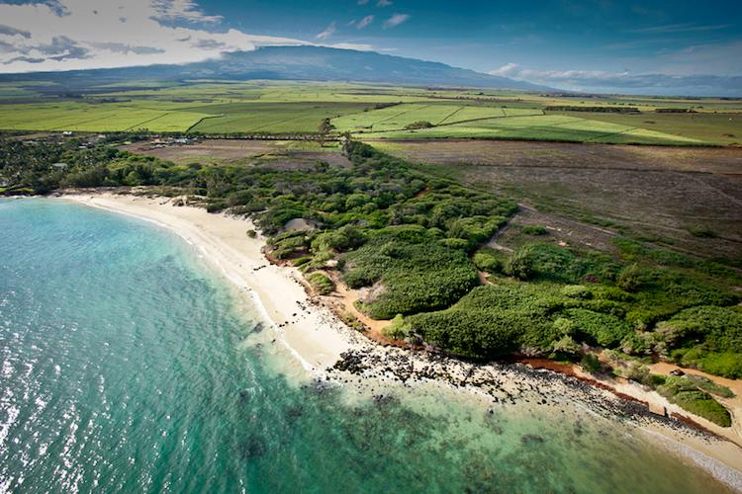

Figure 1. Spreckelsville, Maui, Hawaii

The Hawaiian Island Land Trust (HILT) was established to protect ecologically sensitive landscapes. In 2004, HILT acquired the ownership of the 277 acres Waihe’e Coastal Dunes and Wetland Refuge.4 The program was established to restore and enhance critical ecosystems while preserving historical and cultural resources.5 6 These ecosystems will be inundated in the future by sea-level rise. Thus, the program aims to restore the landscape to what it was in the past.7 With the help of volunteers, over 70% of native species have returned to the landscape.8

*Englishman River Estuary (Parksville BC, Canada):*

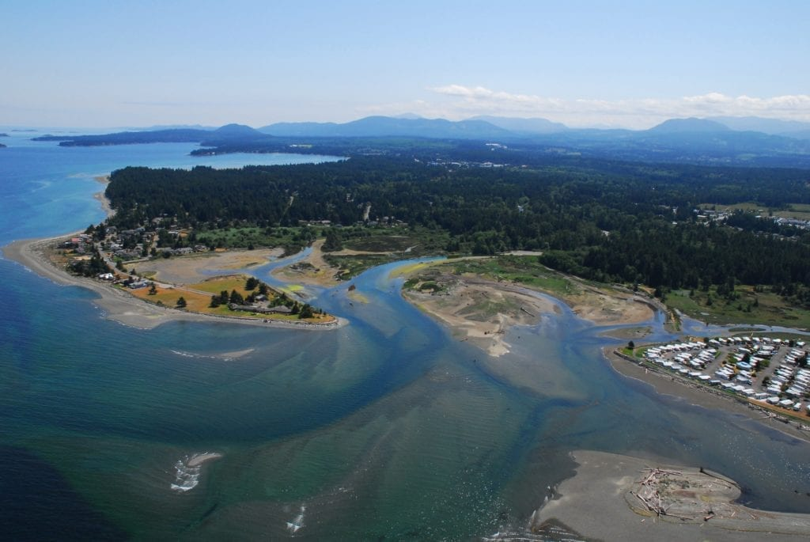

Figure 2. The Englishman River Estuary

In 1992, the Nature Trust of B.C purchased 76.7-hectare Englishman River Estuary with a five-year plan to improve the habitat for fish and wildlife.9 Estuaries are ecologically sensitive landscapes that are important for the stabilization of coastal areas. Estuaries also act as natural buffers in the event of a storm surge. Since the 1930s, the construction of dikes, roads, and residential development have dramatically impacted natural tidal and river processes.10 However, a plan to remove man-made structures such as the abandoned roadway helped to restore natural ecological processes.11 Having a healthy estuary helps to reduce the severity of inland flooding and the impact of tidal waves.

*References:*

1. The Arlington Group Planning Architecture Inc., et al. *Sea Level Rise Adaptation Primer*. pp. 55. https://www2.gov.bc.ca/assets/gov/environment/climate-change/adaptation/resources/slr-primer.pdf
2. Ibid, 56.
3. Ibid, 56.
4. “The Hawaiian Islands Land Trust - Waihe'e Coastal Dunes and Wetlands Refuge.” *Conservation in a Changing Climate*, https://climatechange.lta.org/case-study/hilt_waihee_restoration/.
5. Ibid.
6. Ibid.
7. Ibid.
8. Ibid.
9. “Restoration Work Begins on the Englishman River Estuary.” *The Nature Trust of British Columbia*, 15 Mar. 2018, https://www.naturetrust.bc.ca/news/restoration-work-begins-englishman-river-estuary.
10. Ibid.
11. Ibid.
12. Land Trust Alliance. (2014). The Waihe’e Coastal Dunes and Wetlands Refuge: full case study. Retrieved from <http://www.landtrustalliance.org/climate-change-toolkit/inspire/case-studies/hawaiian-islands>
13. McNair & Harrington. (2016). Land Trusts in BC – The Importance of People Protecting Places. The land conservancy of British Columbia. <https://conservancy.bc.ca/2010/09/land-trusts-in-bc-the-importance-of-people-protecting-places/>
14. Campbell, M. C., & Salus, D. A. (2003). Community and conservation land trusts as unlikely partners. The case of Troy Gardens, Madison, Wisconsin. *Land Use Policy*, *20*(2), 169-180.
15. Bonar, D. (2021). Maui Coastal Land Trust. Coastal adaptation knowledge exchange.https://www.cakex.org/community/directory/organizations/maui-coastal-land-trust
16. Witt, S and Swann, R. (1995). LAND: CHALLENGE AND OPPORTUNITYhttps://centerforneweconomics.org/publications/land-challenge-and-opportunity/
17. Myhr, R. O. (1987). Private Coastline Conservation Management: The Land Trust in the San Juan Islands, Washington. In Coastal Zone'87 (pp. 3266-3273). ASCE.
18. Rissman, A. R., & Butsic, V. (2011). Land trust defense and enforcement of conserved areas. Conservation Letters, 4(1), 31-37.

*Images:*

1. ***Figure 1.*** *Spreckelsville, Maui*. https://images.squarespace-cdn.com/content/v1/57dc7b882994ca976a693629/1475012201416-UVDR4AJLKD2JGAJTXP6K/ke17ZwdGBToddI8pDm48kA9rhCjhJUYcQpKsBaLXN1ZZw-zPPgdn4jUwVcJE1ZvWQUxwkmyExglNqGp0IvTJZamWLI2zvYWH8K3-s_4yszcp2ryTI0HqTOaaUohrI8PIye_uGeP4isZUnhF2J4BSLX0iSmbQA7pLf20f1CNe8SkKMshLAGzx4R3EDFOm1kBS/image-asset.jpeg?format=750w.
2. ***Figure 2.*** *The Englishman River Estuary*. https://www.naturetrust.bc.ca/wp-content/uploads/2017/06/englishman-river-aerial-shot-2017-1024x685.jpg.

**Protected area zoning**

*Overview*

Zoning is a process that gives local and national agencies the autonomy to regulate land use. Usually, zoning regulations are administered at the level of a local authority, municipality, or county (e.g., Australia and the United States) in some other jurisdictions, zoning is regulated at the state or national level (e.g., France and Germany). Zoning could also be regulated by strategies such as environmental impact assessments.1 Zones may also be designated as protected or conservation areas that are used to delimit and define units of land for conservation and recreational activities. According to the IUNC “a protected area is a clearly defined geographical space, recognized, dedicated and managed, through legal or other effective means, to achieve the long term conservation of nature with associated ecosystem services and cultural values” [(IUCN Definition 2008)](https://www.iucn.org/theme/protected-areas/about#:~:text=What%20is%20a%20protected%20area%3F&text=Protected%20areas%20%E2%80%93%20national%20parks%2C%20wilderness,particularly%20at%20the%20local%20level.). Protected areas are generally established to protect biodiversity and preserve the integrity of ecosystem processes. Protected area zoning PAZ is applied widely for the protection of both marine and terrestrial areas. Some jurisdictions may allow limited development within PAZs. For example, in Prince Edwards Island, in Atlantic Canada, a limited amount of development is allowed within a zone that is designated as an [Environment Protection Zone](http://www.osmtownship.ca/en/township-hall/resources/Documents/Section_21_-_Environmental_Protection_EP_Zone.pdf). However, in most instances, Buffer Management Zones are established as a transition area between protected areas and private lands. Generally, the establishment of Protected area zoning serves as an effective strategy for avoiding development within environmentally sensitive areas. 2

*Types of protected areas:*

* **Strict nature reserves** are protected areas that are zoned for the protection of biodiversity, geological and geomorphological features. Anthropogenic impacts are controlled through strict conservation measures and values. Strict nature reserves can serve as reference areas for scientific research and monitoring.
* **Protected areas with sustainable use of natural resources** are used to conserve ecosystems and habitats in addition to cultural values. Although most of the protected area is preserved in its natural condition, low-level non-industrial use is permitted.
* **Protected landscape/seascapes** are areas where the ecological, biological, cultural, and scenic values have been shaped by the interaction of people and nature over time. Safeguarding this interaction is therefore vital to protecting and conserving the ecological integrity and value of the area.
* **National parks** are large natural or near natural areas that are designated to protect large-scale ecological processes and that complement the ecosystem characteristics of an area. 3

*Benefits*:

* Provides a haven for the sustenance of wild flora and fauna in coastal marine and terrestrial areas
* Sustains and strengthens indigenous values and knowledge, particularly, their application to the conservation of landscapes and cultural practices.
* Helps to mitigate against the effects of extreme weather conditions, acts as a sink for and source of carbon
* Serves as an environmental benchmark that can be used for monitoring the health of natural ecological systems and for understanding the effects of climate change, pollution, and the extraction of natural resources on ecological and biological systems. 4 5
* Fosters inclusive environmental stewardship and transboundary decision making among diverse groups and community interests, e.g., indigenous peoples, local communities, and private actors. 6

*Challenges*

* Uncertainty with the designation of some conventions within a protected area management regime, e.g., it is still not clear when RAMSAR sites are protected areas
* May create a false sense of security and may not achieve conservation goals where protected area systems do not achieve what they were established to do and exist solely as “paper parks”
* Increasing propensity of some governments to downsize, downgrade, and degazette protected area legislation without significant consequence.
* Existing and growing antipathy among different interests regarding the idea of protected area. For example, tensions between academics and human rights groups regarding conversation and community access to protected area resources.
* Ignorance at different levels of government and private interests regarding the role of protected area management. This ignorance manifest in the lack of legislative, and policy support and financing
* Existing legislation might lag behind globally acceptable best practices related to social and conservation outcomes. 7

*Kaa-Iya del Gran Chaco National Park (Bolivia)*

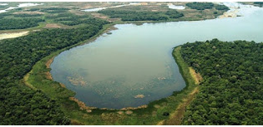

Figure 1. KAA - Iya del Gran Chaco National Park and Natural Area of ​​Integrated Management

During the mid-1990s, the indigenous IsoseñoGuaraní people in Bolivia proposed the establishment of the Kaa-Iya del Gran Chaco National Park (KINP). The park occupies 3.4 million acres of land and is located in a lowly populated area in the eastern region of Bolivia that had been traditionally used for farming. However, industrialization had led to a rapid expansion in commercial agriculture and petroleum extraction in the region. Therefore, the park was created as a buffer around the territory of the IsoseñoGuaraní people. The legislation that established the park allowed for the extraction of resources from three designated zones. It also provided for the development of a management plan, which identified core protected areas within which resources could not be extracted and for special uses. The status of the park is preserved under a communal title that ensures that there is no subdivision or sale of land with the protected area. 8

*Ontario Greenbelt (Ontario, Canada)*

Commonly referred to as the Greater Golden Horseshoe (GGH), the Ontario greenbelt is one of the most dynamic and rapidly expanding regions in North America. The region supports two-thirds of Ontario’s population and more than one-quarter of the entire population of Canada. Located in the heart of the great lakes, the GGH contains some of Canada’s ecological and hydrologically sensitive environmental and scenic landscapes, including, productive farmland, and an abundant water supply. In 2005, Ontario developed the Greater Golden Horseshoe Growth Plan. The plan helps to determine where and how future growth should occur within the region, particularly what should be protected for future generations. The plan identifies protected countryside lands within the greenbelt that are intended to enhance the spatial parameters of agriculture and environmentally protected lands while improving linkages between protected areas, surrounding lakes, and watersheds**.** 9

.

*References*

1. The World Bank. (2015). Zoning and land use planning. <https://urban-regeneration.worldbank.org/node/39#:~:text=The%20purpose%20of%20zoning%20is,down%20development%20in%20specific%20areas4>
2. Herrera-Montes, M. I. (2018). Protected Area Zoning as a Strategy to Preserve Natural Soundscapes, Reduce Anthropogenic Noise Intrusion, and Conserve Biodiversity. Tropical Conservation Science, 11, 1940082918804344.
3. Dudley et al. (2015). Chapter 6 Values and Benefits of Protected Areas. <https://core.ac.uk/download/pdf/132677617.pdf>
4. Bell, A. (2007). Top 10 reasons for protected areas. Ontario Nature. <https://ontarionature.org/top-10-reasons-for-protected-areas/#:~:text=Protected%20areas%20help%20to%20mitigate,adapt%20to%20a%20changing%20climate.&text=4.,soils%2C%20wild%20foods%20and%20medicines>
5. Dudley, N. (n.d).Guidelines for Applying Protected Area Management Categories. https://portals.iucn.org/library/sites/library/files/documents/PAG-021.pdf
6. IUCN. (n.d). What is a protected area? https://www.iucn.org/theme/protected-areas/about
7. Dudley and Stolton. (2018). PROTECTED AREAS: challenges and responses for the coming decade. Equilibrium Research. http://www.equilibriumconsultants.com/upload/document/Equilibrium_Research_Dialogue_1.pdf
8. Naughton, l. (2007). COLLABORATIVE L AND USE PLANNING: Zoning for Conservation and Development in Protected Areas. Tenure Brief. University of Madision. https://www.nelson.wisc.edu/ltc/docs/!ltcbrief4-zoning_protected_areas.pdf
9. Ministry of Municipal Affairs and Housing, Ontario. (2019). Greenbelt Plan (2017). https://www.ontario.ca/document/greenbelt-plan-2017

*Images*

1. Figure 1. De Julio De. (2016).KAA - Iya del Gran Chaco National Park and Natural Area of ​​Integrated Management. Protected Areas: Bolivia. http://protarbol.blogspot.com/2016/07/kaa-iya-del-gran-chaco-national-park.html